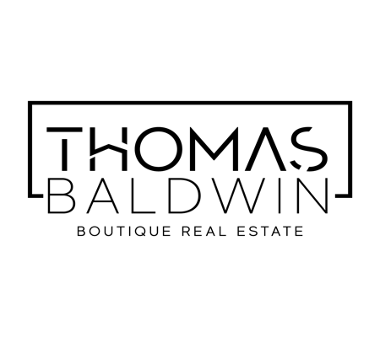
Privacy Statement
Thomas Baldwin PTY LTD 633 314 324 trading as Thomas Baldwin Boutique Real Estate is committed to protecting your privacy in compliance with the Privacy Act 1988 (Cth) and the Australian Privacy Principles (APPs). This document sets out Thomas Baldwin Boutique Real Estate’s condensed Privacy Notice. Thomas Baldwin Boutique Real Estate also has a full Privacy Policy, which contains information about how you can complain about any breach by Thomas Baldwin Boutique Real Estate of the APPs or an applicable APP Code. A full copy of our Privacy Policy can be accessed on our website at www.thomasbaldwin.com.au.

Information Collection, Use and Disclosure
During the course of your involvement with Thomas Baldwin Boutique Real Estate, we may collect, use or disclose personal information about you for the following purposes:
- Assisting you to sell your property;
- Assisting you to purchase a property;
- Assisting you to lease a property (either as lessor or lessee);
- Assisting you to obtain a loan;
- Assisting you with payment or refund of a bond;
- Assisting you with tenancy disputes;
- Coordinating repairs or maintenance of a property owned or leased by you;
- Recording or accessing information at the Titles Registry Office or other government agency;
- Recording or accessing information at the Residential Tenancies Authority;
- Recording or accessing information on tenancy information services or databases;
- Client and business relationship management;
- Marketing of products and services to you;

The types of personal information we may collect, use or disclose about you includes but is not limited to:
- Your full name;
- Your date of birth;
- Your residential address;
- Your postal address;
- Your email address;
- Your home telephone number;
- Your work telephone number;
- Your mobile telephone number;
- Your occupation and business address;
- Financial information including details of your employer, income, name of bank or financial institution;
- Details of your spouse, de facto, dependent children, and roommates;
- Details of properties owned by you;

In order to provide products and services to you, we may disclose your personal information to the persons/organisations described below:

- In the event that you are a seller or a lessee, we may disclose your personal information to prospective buyers of the property owned or leased by you;
- In the event that you are a buyer or a lessee, we may disclose your personal information to the sellers of the property you are purchasing or leasing;
- Your legal advisor(s) and the legal advisor(s) representing the other party(s) involved in your transaction;
- Your financial institution and/or financial advisor;
- Insurance providers and brokers;
- Utility providers and utility connection service providers;
- Persons or organisations involved in providing, managing or administering your product or service including independent contractors engaged by us as real estate agents;
- Tradespeople engaged by us to repair or maintain a property owned or leased by you;
- Organisations involved in maintaining, reviewing and developing our business systems, procedures and infrastructure including maintaining or upgrading our computer systems;
- Persons or organisations involved in purchasing part or all of our business;
- Our related companies;
- Organisations involved in the payments systems including financial institutions, merchants and payment organisations;
- The Titles Registry Office or other government agencies;
- The Residential Tenancies Authority;
- Police;
- Tenancy information services or databases;
- Real estate websites;
- Real estate peak bodies;

Whenever it is reasonable or practicable to do so, we will collect your personal information directly from you. Sometimes it will be necessary for us to collect information from a third party or a publicly available source, such as a credit reporting agency, your legal adviser, your past or current employers, your previous lessors or property managers, and tenancy information services or databases.

In the course of providing services to you, it may be necessary for us to enter your personal information into forms generation software and real estate websites. Depending on the terms of use of such software and websites, a third party may acquire rights to use or disclose information entered into the relevant forms or websites.

We may disclose your personal information to recipients within Australia or to overseas recipients Should information be required to be sent interstate or overseas, we will take steps to protect the privacy of your information.

We need your permission to collect, use and disclose your personal information, and we therefore ask that you sign the consent on the first page of this document to indicate your consent.

In the event that you do not consent to Thomas Baldwin Boutique Real Estate collecting and releasing your personal information as described above, we may be unable to provide the services requested by you.

Access to, and correction of personal information
You have the right to request access to your information and to request that ThomasBaldwin Boutique Real Estate update or correct your personal information. A charge may apply for providing access to your information.

Our Privacy Policy contains further information about how you may request access to, and correction of, your personal information.

Contacting Us
You may contact us by mail, email or telephone as follows:

36A Leonard Street Kewarra Beach
☎
0407091834

hello@thomasbaldwin.com.au

